University Of H-Town

[Student Database]

[Joseph Shoboiki, Esteban Mejia]

* **Abstract:**
* **Mission Statement:**

The purpose of this database system is to create an easy way of accessing one’s courses. Professor’s will be able to manage their lectures and students’ grades and students can keep track of their courses and any information and work the professor’s upload.

* **Mission Objectives:**

To maintain (enter, update, and delete) data on students.

To maintain (enter, update, and delete) data on courses.

To maintain (enter, update, and delete) data on grades.

To maintain (enter, update, and delete) data on workload.

To perform searches on students.

To perform searches on courses.

To perform searches on grades.

To perform searches on workload.

* **Major User Views:**

|  |  |  |  |  |
| --- | --- | --- | --- | --- |
| **Data** | **Access Type** | **Students** | **Staff (Professor)** | **Administrator** |
| Students | Manages  Queries | X  X | X | X |
| Professors | Manages  Queries | X | X | X |
| Courses | Manages  Queries | X | X | X |
| Login | Manages  Queries | X | X | X |
| Course Home Page | Manages  Queries | X | X | X |

* **ER Diagram:**

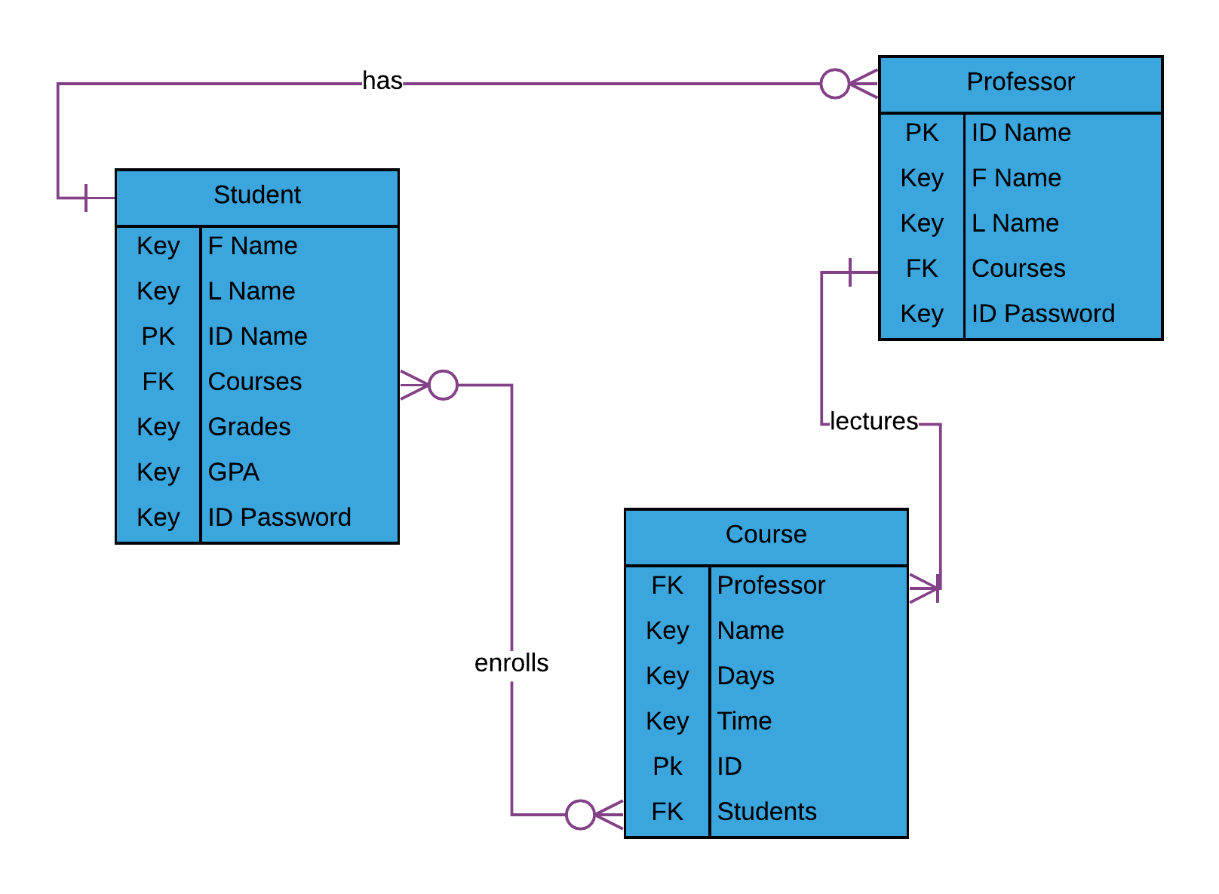

* **Relational Model:**

**Students:**

|  |  |  |  |  |  |  |
| --- | --- | --- | --- | --- | --- | --- |
| ID | F_Name | L_Name | Password | Courses | Grades | GPA |
| Mejiaavel6 | Esteban | Mejia | 08ULgZFt | CS Senior Seminar,  CS Operating System | A,  B | 122 |
| Richytive13 | Richard | Richy | EbKJGS4q | CS Pro Lang Concepts, CS Operating System, CS Senior Project, CS Database | B,  C,  B,  A | 22 |
| ScottYlid6 | Michael | Scott | LB7HQLxp | CS Pro Lang Concepts, CS Operating System, CS Senior Project, CS Database | C,  C,  B,  D | 45 |
| BenitezSic9 | Jane | Benitez | P5HPfKzo | CS Senior Seminar, CS Pro Lang Concepts, CS Operating Systems, CS Database | A,  C,  B,  A | 120 |
| OsbornePi16 | Bert | Osborne | FpYmxG8D | CS Pro Lang Concepts, CS Operating Systems, CS Senior Project | D,  B,  C | 66 |
| GriffithPieta17 | Guts | Griffith | iiTo9tsh | CS Senior Seminar, CS Pro Lang Concepts, CS Operating Systems,  CS Database | A,  B,  A,  A | 100 |
| CarterSauf20 | Andy | Carter | crMDjN7B | CS Senior Project, CS Database | B,  D | 0 |
| LanisterDoh5 | Jamie | Lanister | eJ7j99ED | CS Pro Lang Concepts, CS Senior, Project | A,  A | 66 |
| ShoboikiBel8 | Joseph | Shoboiki | onnnL8R8 | CS Operating Systems, | C | 126 |
| TainMejia2 | Claudia | Mejia | 8kf8HSzr | CS Senior Project, CS Pro Lang Project, CS Operating Systems, | C,  F,  B | 120 |
| JureJames14 | Aubrey | James | o6yqr4dM | CS Operating Systems, CS Senior Project | B,  A | 120 |

**Courses:**

|  |  |  |  |  |  |
| --- | --- | --- | --- | --- | --- |
| ID | Name | Professor | Days | Time | Students |
| 4294 | CS Senior Seminar | Speed Wagon | M | 1-2:15pm | Esteban Mejia  Jane Benitez  Guts Griffith  Claudia Mejia |
| 4303 | CS Pro Lang Concepts | Dio Brando, Orihime Inoue | T, TH | 4-5:15pm, 5-7:15pm | Richard Richy  Michael Scott  Jane Benitez  Richard Richy  Bert Osborne  Guts Griffith  Jamie Lanister  Claudia Mejia |
| 4315 | CS Operating Systems | Jonathon Joestar, Dio Brando, Speed Wagon | TH | 10-12:45pm, 3-4:45pm, 2-3:45pm | Esteban Mejia  Michael Scott  Jane Benitez  Richard Richy  Guts Griffith  Bert Osborne  Joseph Shoboiki  Claudia Mejia  Aubrey James |
| 4395 | CS Senior Project | Penelope Cruz | W | 3:30-4:15pm | Richard Richy  Michael Scott  Bert Osborne  Jamie Lanister  Aubrey James  Andy Carter |
| 4313 | CS Database | Orihime Inoue | M, W, F | 10:30-11:45am | Jane Benitez  Michael Scott  Guts Griffith  Richard Richy  Andy Carter |

**Professor**

|  |  |  |  |  |
| --- | --- | --- | --- | --- |
| ID | F_name | L_Name | Courses | Password |
| InoueZule | Orihime | Inoue | CS Pro Lang Concepts, CS Databse | bE4FtepzaSh6 |
| WagonREO | Speed | Wagon | CS Senior Seminar, CS Operating System | kS8TAK9MeEq9 |
| 63956 | Penelope | Cruz | CS Senior Project | 36364456 |
| JoeJo | Jonathon | Joestar | CS Operating Systems | FLNDa3PeCLRi |
| TheWorld | Dio | Brando | CS Pro Lang Concepts, CS Operating System | G9y6LFGXsxEf |

* **Use Cases:**

Login:

* Insert Query
  + Actor: Student/Professor/Administrator
  + Steps:
    - User selects the “Username” field
    - User enters their unique ID
    - User then selects “Password” field
    - User enters password
    - User either clicks login or “enter” on keyboard
  + SQL:

INSERT INTO Login (ID, password)

VALUES (“ScottYlid6”, “LB7HQLxp”);

Course info/workload:

* Insert Query
  + Actor: Professor
  + Steps:
    - User selects the “Upload” option
    - A message is displayed to prompt the user to choose a file
    - User selects file
    - File uploaded
* Delete Query
  + Actor: Professor
  + Steps:
    - User selects the “Delete” option.
    - Prompt the user to select which file that they want to delete
    - Message displays asking if user is sure they want to delete file
    - File is deleted
* Update Query
  + Actor: Proffesor
  + Steps:
    - User selects the “Update information” option
    - Prompt the user to choose which file they would like to update
    - User selects file they wish to update
    - User browses for new file
    - User selects new file
    - File is updated

Courses Announcement:

* Insert Query
  + Actor: Professor
  + Steps:
    - User selects the “Add Announcement” option
    - User types announcement
    - User clicks enter or presses enter on keyboard
    - Announcement added

Course Grades:

* Insert Query
  + Actor: Professor
  + Steps:
    - User selects the “Add” option
* Delete Query
  + Actor: Professor
  + Steps:
    - User selects the “Delete” option.
* Update Query
  + Actor: Proffesor
  + Steps:
    - User selects the “Update information” option

Course Student:

* Insert Query
  + Actor: Student
  + Steps:
    - User selects the “Upload” option
    - A message is displayed to prompt the user to choose a file
    - User selects file
    - A 2nd message prompts the user for confirmation
    - File uploaded